
Java Script Notes

AUGUST 2, 2023
DUCAT
Noida

Table of Content
S.No. | Topic Name | Page No.
 | Introduction to Java Script
 | History and Features of Java Script
 | Applications and Limitations
 | Difference between programming language and scripting language
 | JS comments and JS variables
 | Difference between let, var and const keywords, Scope, Hoisting
 | Data Types, Type Conversion and Type Casting
 | JS Input/Output Methods
 | Switch statement
 | Operators
 | Loops
 | Functions
 | Objects
 | Date and String Object Methods
 | Number and Math Object Methods
 | Regular Expression

Introduction: JavaScript is a lightweight, cross-platform, single-threaded, and interpreted compiled programming language which is also known as the scripting language for webpages. It is well-known for the development of web pages, and many non-browser environments also use it. JavaScript is an object-based scripting language.
- With JavaScript, users can build modern web applications to interact directly without reloading the page every time.
- Although, JavaScript has no connectivity with Java programming language. The name was suggested and provided in the times when Java was gaining popularity in the market.
- JavaScript is a weakly typed language(dynamically typed). JavaScript can be used for Client-side developments as well as Server-side developments.
- JavaScript is both an imperative and declarative type of language. JavaScript contains a standard library of objects, like Array, Date, and Math, and a core set of language elements like operators, control structures, and statements.
- Client-side: "client-side" refers to the part of web development where code is executed on the user's web browser. When the user visits the page, their web browser downloads and executes the JavaScript code directly on their device. Client-side JavaScript is commonly used to add interactivity and dynamic behaviour to web pages.
- It supplies objects to control a browser and its Document Object Model (DOM).
- Useful libraries for the client side are AngularJS, ReactJS, VueJS, and so many others.
- Examples of client-side JavaScript functionality include form validation, interactive user interfaces, dynamic content loading (e.g., AJAX), animations, and more.
- Server-side: "server-side" refers to the execution of JavaScript code on the server rather than on the client's browser. JavaScript is a versatile programming language that can be used in various environments, including the server-side and the client-side.
- This allows developers to build server-side applications, manage databases, handle business logic, and perform other server-side tasks.
- The useful framework which is the most famous these days is node.js. Node.js is an open-source, cross-platform. JavaScript runtime environment that enables developers to run JavaScript code outside of a web browser.
- It allows for code reuse and consistent programming languages across both client and server environments, making it a popular choice for full-stack web development.
- cross-platform: "cross-platform" in JavaScript refers to the ability of a program or application to work on different types of devices or operating systems without any major changes. It means that you can write the code once, and it will run smoothly on various platforms, such as computers, smartphones, tablets, and more.
- JavaScript can be added to your HTML file in two ways:
- Internal JS: We can add JavaScript directly to our HTML file by writing the code inside the <script> tag. The <script> tag can either be placed inside the <head> or the <body> tag according to the requirement.
Syntax:- <script>
// JavaScript Code
</script>

- External JS: We can write JavaScript code in other files having an extension .js and then link this file inside the <head> tag of the HTML file in which we want to add this code.
Syntax:-
<script type="text/javascript" src="JS file"></script>

History of JavaScript
It was created in 1995 by Brendan Eich while he was an engineer at Netscape. It was originally going to be named LiveScript but was renamed. Unlike most programming languages, JavaScript language has no concept of input or output. It is designed to run as a scripting language in a host environment, and it is up to the host environment to provide mechanisms for communicating with the outside world.
Features of JavaScript:
1. Can handle date and time.
2. Performs Form Validation although the forms are created using HTML.
3. No compiler is needed.
4. Functions in JS are objects. They may have properties and methods just like other objects. They can be passed as arguments in other functions.
5. JS is used to create dynamic Web sites.
6. JavaScript is a dynamically typed language, where certain types are implicitly cast (depending on the operation).
7. JavaScript is an object-based programming language that uses prototypes rather than using classes for inheritance.
8. It is a case-sensitive language.

Why JavaScript is known as a lightweight programming language?
- "lightweight" refers to something that is small, simple, and efficient.
- The advantage of using lightweight solutions is that they load faster, take up less memory, and can make your website or application more responsive.
- Overall, lightweight in JavaScript means simplicity, efficiency, and only including what's necessary to get the job done, making your code faster and more manageable.
- JavaScript is known as a "lightweight" programming language due to several key characteristics—
1. Easy to Learn and Use: Its syntax is similar to other popular programming languages, which lowers the learning curve for those familiar with programming concepts.
It is very easy to learn because of its syntax similar to C++ and Java.
2. Interpreted Language: JavaScript is an interpreted language, meaning it doesn't require a compilation step like some other languages. This allows developers to write code and see results immediately without the need for an additional compilation process.
3. Client-Side Execution: JavaScript primarily runs on the client-side, meaning it runs directly in a user's web browser. This eliminates the need for server-side processing for certain tasks, reducing server load and making it lightweight for the server.
4. Supports Functional Programming: "JavaScript supports functional programming" means that JavaScript allows you to use a programming style called "functional programming."
In functional programming, you write your code in a way that focuses on using small, reusable functions to perform specific tasks. These functions take some input (data) and produce an output (result) without changing any data outside of the function.
5. Dynamic Typing: JavaScript is dynamically typed, meaning variable types are determined during runtime.

Is JavaScript compiled or interpreted or both?
- JavaScript is primarily an interpreted language. It was designed to be executed directly in web browsers without the need for a separate compilation step. When a web page containing JavaScript code is loaded in a browser, the browser's JavaScript engine interprets the code line by line and executes it immediately.
- However, there are cases where JavaScript is also compiled. Some modern JavaScript engines, like V8 (used in Chrome and Node.js), use a combination of interpretation and compilation techniques to optimize the execution of JavaScript code. They use a process called "Just-In-Time" (JIT) compilation.
- JavaScript is both compiled and interpreted.
- In the earlier versions of JavaScript, it used only the interpreter that executed code line by line and shows the result immediately. But with time the performance became an issue as interpretation is quite slow.
- Therefore, in the newer versions of JS, probably after the V8, the JIT compiler was also incorporated to optimize the execution and display the result more quickly. This JIT compiler generates a bytecode that is relatively easier to code. This bytecode is a set of highly optimized instructions.

Applications of JavaScript:
- Web Applications: When we explore a map in Google Maps then we only need to click and drag the mouse. All detailed view is just a click away, and this is possible only because of JavaScript. It uses Application Programming Interfaces(APIs) that provide extra power to the code. The Electron and React are helpful in this department.
- Server Applications: With the help of Node.js, JavaScript made its way from client to server and Node.js is the most powerful on the server side.
- Games: Not only in websites, but JavaScript also helps in creating games for leisure. The combination of JavaScript and HTML 5 makes JavaScript popular in game development as well. It provides the EaseJS library which provides solutions for working with rich graphics.
- Smartwatches: JavaScript is being used in all possible devices and applications. It provides a library PebbleJS which is used in smartwatch applications.
- Art: Artists and designers can create whatever they want using JavaScript to draw on HTML 5 canvas, and make the sound more effective also can be used p5.js library.
- Machine Learning: This JavaScript ml5.js library can be used in web development by using machine learning.
- Mobile Applications: Using React Native, we can build mobile applications for different operating systems. We do not require to write code for different systems. Write once use it anywhere!
- Client-side validation
- Dynamic drop-down menus
- Displaying date and time
- Displaying pop-up windows and dialog boxes (like an alert dialog box, confirm dialog box and prompt dialog box)
- Displaying clocks etc.

Limitations of JavaScript:
- Client-Side Security:

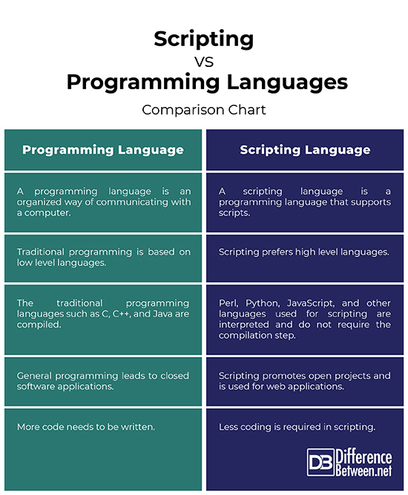
Difference between programming language and scripting language?

JavaScript Comments
The JavaScript comments are meaningful way to deliver message. It is used to add information about the code, warnings or suggestions so that end user can easily interpret the code.
The JavaScript comment is ignored by the JavaScript engine i.e. embedded in the browser.

Advantages of JavaScript comments
- To make code easy to understand It can be used to elaborate the code so that end user can easily understand the code.
- To avoid the unnecessary code, it can also be used to avoid the code being executed. Sometimes, we add the code to perform some action. But after sometime, there may be need to disable the code. In such case, it is better to use comments.

Types of JavaScript Comments
There are two types of comments in JavaScript.
- Single-line Comment ( // )
- Multi-line Comment ( /* your code here */ )
JavaScript Variables
Variables are Containers for Storing temporary Data. and variable name are the name of memory location. There are two types of variables:
- Local variables: - A JavaScript local variable is declared inside block or function. It is accessible within the function or block only.
- Global variables: - A JavaScript global variable is declared outside the function or declared with window object. They can be accessed from anywhere. If you are not specify let, var or const keyword on the time of variable declaration, they are by default global variables. Exp. X=20;
e.g.,
<script>
function m(){
window.value=100 //Declaring/Initializing global variable by window object into the function
x = 200; // Global variable
}
function n(){
alert(window.value, x); //accessing global variable from other function Output: 100 200
}
m();
n();
</script>
Rules variable name while declaring a JavaScript variable:
- Name must start with a letter (a to z or A to Z), underscore ( _ ), or dollar ( $ ) sign.
- After first letter we can use digits (0 to 9), letter, _ or $, for example value1.
- JavaScript variables are case sensitive, for example x and X are different variables.
Note: JavaScript Variables can be declared using 4 ways: —
- automatically
- using var
- using let
- using const
The var keyword was used in all JavaScript code from 1995 to 2015.
The let and const keywords were added to JavaScript in 2015.
The var keyword should only be used in code written for older browsers.
Declaring a Variable: Creating a variable is called "declaring" a variable.
e.g., var carName; or let carName;
After the declaration, the variable has no value (technically it is undefined).
To assign a value to the variable. carName = "Volvo";
One Statement, Many Variables:
e.g., let person = "John Doe", carName = "Volvo", price = 200;
Re-Declaring JavaScript Variables:
If you re-declare a variable using var, it will not lose its value.
var carName = "Volvo";
var carName;
You cannot re-declare a variable using let or const.

Example of local variable and Global variable:
<script>
var value=50; // Declaring global variable
function m(){
var value=20; // Declaring local variable
window.value=100; //Change value of global variable
alert(“Inside the function m() ”+value); // Inside the function m() 20
}
m();
alert(“Outside function "+value); // Outside function 100
</script>

Basic of difference | var | let | const
scope | Function-scope | Block-scope | Block-scope
Re-declaration | Yes | No | No
Re-assignment | Yes | Yes | No
hosting | They are hoisted to the top of their function-scope (global scope if not inside a function or local scope if inside a function), which makes them accessible before the line they are declared. But the variable is hoisted with a default value of undefined.  undefined * undefined which results in NaN. | They are hoisted to the top of their block scope, but they are not initialized until the actual declaration statement is reached. So, it will be giving a reference error: Cannot access before initialization | They are hoisted to the top of their block scope, but they are not initialized until the actual declaration statement is reached. So, it will be giving a reference error: Cannot access before initialization
Difference between let, var and const keywords—
Global scope
Ques. What are the types of scope in JS?
Ans. There are three types of scopes in JavaScript:
Local scope or Function scope
  - Global-scope
Block Scope
  - Local-scope or Function-scope
  - Block-scope.
- Global-scope: Variables declared outside of any function are in the global scope. They can be accessed from anywhere in the program.
Eg 2:
If(true) {
var x = 10; // function-scoped variable
let y = 50; // block-scoped variable
const z = 70; // block-scoped variable
console.log(x, y, z); // 10 50 100
}
console.log(x); // 10
console.log(y); // Error: y is not defined
console.log(z// Error: z is not defined
Eg 1:
var x = 10; // Global-scoped variable
function myFun() {
var y = 20; // Function-scoped variable
let z = 50; // block-scoped variable
console.log(x, y, z); // 10 20 50
}
myFun();
console.log(x); // 10
console.log(y); // Error: y is not defined
console.log(z); // Error: z is not defined

- function-scope or local-scope: Variables declared inside of a function are in the local scope. They can only be accessed from within that function. They are not accessible outside of that function.
- Variable declared using var keyword they always will be considered as in function scope. Whether you declared these variables in block-scope or in function scope. You can access these variables from anywhere within the function scope and block scope.
function myFun() {
var x = 10; // Function-scoped variable
console.log(x); // 10
}
myFun();
console.log(x); // Error: x is not defined

function myFun() {
if(true){
var x = 10; // function-scoped variable
console.log(x); // 10
}
console.log(x); // 10
}
myFun();

- block-scope: Variables declared using let and const are block-scoped, which means they are only accessible within the block (a set of curly braces {}) where they are declared.
Variables declared inside of a block of code, such as an if statement or a loop, are in the block scope. They can only be accessed from within that block of code.
(i.e., each function-scope can be block-scope but each block-scope cannot be function-scope).
- Variable declared using let or const keyword they always will be considered as in block scope. If you declared these variables in block-scope then they will be accessible only within the block and if you declared these variables in function-scope then they will be accessible only within the function
function myFun() {
let x = 10; // function-scoped variable
const y = 20; // function-scoped variable
console.log(x, y); // 10 20
}
myFun();
console.log(x); // Error: x is not defined
console.log(y); // Error: y is not defined

function myFun() {
if(true){
let x = 10; // block-scoped variable
const y = 50; // block-scoped variable
console.log(x, y); // 10 50
}
console.log(x); // Error: x is not defined
console.log(x); // Error: y is not defined
}
myFun();

Block 1

Block 2

Ques. What is hoisting? Explain types of hoisting?
Ans. Hoisting is the default behaviour of moving all the declarations at the top of the scope before code execution. i.e., Hoisting means that when you write code to declare a variable, function, or class in JavaScript, the interpreter moves that declaration to the top of its current scope (either the global scope or a local(function) scope) before any code actually runs. So, you can use those variables, functions, or classes before you actually declare them.
Note: When the interpreter hoists a variable declared with var, it initializes its value to undefined.
Types of hoisting –
There are three types of hoisting in JavaScript:
    - Variable hoisting
    - Function hoisting.
    - Class hoisting

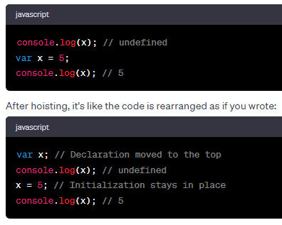
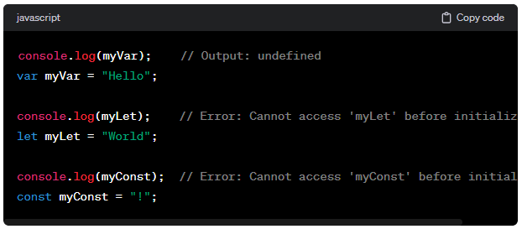
  - Variable hoisting: When you declare a variable using `var`, `let`, or `const`, JavaScript moves all the variable declarations to the top of their scope they are defined in, before any code executes. This means that you can use a variable before it is declared. E,g.,

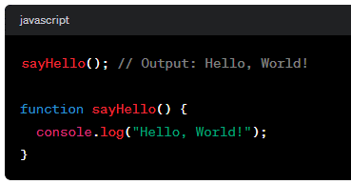
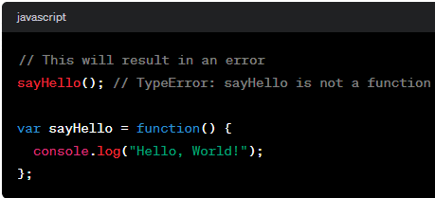
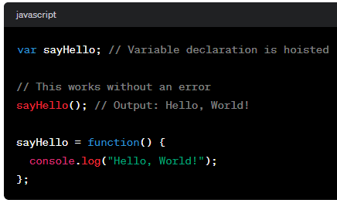
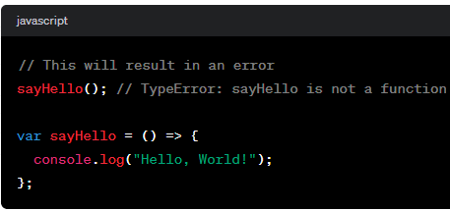
  - Function hoisting: When you declare a function using `function`, JavaScript moves its declaration to the top of their scope they are defined in, before any code executes. This means that you can call the function before declare it.
  - Class hoisting: When you declare a class using `class`, JavaScript moves its declaration to the top of their scope they are defined in, before any code executes. This means that you can access the class before you declare it.
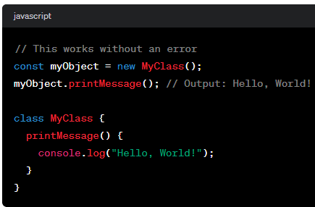

Data types
JavaScript provides different data types to hold different types of values. There are two types of data types in JavaScript.
- Primitive data types
- Non-primitive (reference) data types
JavaScript is a dynamic type language, means you don't need to define or specify type of the variable because it is dynamically used by JavaScript engine. You need to use var here to specify the data type. It can hold any type of values such as numbers, strings etc.
typeof() method is used to check the type of a variable.
- Primitive data type:
Data Type | Description | Create Object  Using new
String | Used to stored text or characters, like “Hello Shivam”. | Yes
Number | Used to represent numerical values e.g., 10, 3.14 or -10. | Yes
Boolean | Represents boolean value either false or true, used for logical operation. | Yes
Undefined | When a variable is declared but hasn’t been assign a value yet. | No
Null | Represents null i.e. no value at all | No
Symbol
Big int | e.g., 548782738085897528975482745783n

- Non-primitive (reference) data types or Complex data type: These are more advanced and can hold multiple values or other data type.
Data Type | Description | Create Object  Using new
Object | Used to store key-value pairs, like {name: ’Shivam’, age: 30}. | Yes
Array | Used to store collection of values, like [1,2,3] or [“Apple”, “Banana”, ”Orange”]. | Yes
Functions | Used to define reusable blocks of code that can be called with arguments.
RegExp | Represents regular expression | Yes

Note:
- A JavaScript variable can hold any type of data.
- When adding a number and a string, JavaScript will treat the number as a string.
- JavaScript has dynamic types. This means that the same variable can be used to hold different data types or no need to specifies data type on compile time:
let x; // Now x is undefined
x = 5; // Now x is a Number
x = "John"; // Now x is a String
- Strings are written with quotes. You can use single or double quotes.
- You can use quotes inside a string, as long as they don't match the quotes surrounding the string:
Output: It's alright
He is called 'Johnny'
He is called "Johnny"
let answer1 = "It's alright";
let answer2 = "He is called 'Johnny'";
let answer3 = 'He is called "Johnny"';

- Extra-large or extra small numbers can be written with scientific (exponential) notation:
let y = 123e5; // 12300000
let z = 123e-5; // 0.00123

- JavaScript has only one type of number. Numbers can be written with or without decimals.
let x = 3.14; // A number with decimals
let y = 3; // A number without decimals
Output: 3030
- let x = 10, y = 20;
let z = "30";
let result = x + y + z;
The JavaScript interpreter works from left to right. First 10 + 20 is added because x and y are both numbers. Then 30 + "30" is concatenated because z is a string.
- JavaScript number are always 64-bit Floating point—
Unlike many other programming languages, JavaScript does not define different types of numbers, like integers, short, long, floating-point etc.
- JavaScript uses the + operator for both addition and concatenation.
- JavaScript will try to convert strings to numbers in all numeric operations:
let x = "100";
let y = "10";
let z = x / y;
Output: 10
console.log(z);

But this will not work:
Output: 10010
let x = "100";
let y = "10";
let z = x + y;

Type Conversion and Type Casting in JS
Type Conversion refers to the process of converting a value from one data type to another.
- Implicit Type Conversion (also known as implicit type coercion or automatic type conversion)
- Explicit Type Conversion (also known as Type casting or explicit type coercion)

- Implicit Type Conversion: This is the process by which JavaScript automatically converts one data type into another during operations or assignments where different data types are involved.
Implicit type casting performs:
- Arithmetic Operators: When you use Arithmetic operators like `+`, `-`, `/`, `*`, `%`, etc., JavaScript automatically converts data types to numbers as required for comparison.
Operation | Example | Result
Addition (+) | 5 + "10" | "510" (string concatenation)
Addition (+) | +true | 1 (Boolean converted to number)
Addition (+) | +false | 0 (Boolean converted to number)
Addition (+) | + “Hello” | 1 (string converted to number)
Addition (+) | + “” | 0 (string converted to number)
Addition (+) | true + 5 | 6 (Boolean true is converted to 1)
Subtraction (-) | 10 - "5" | 5 (string converted to number)
Subtraction (-) | "5" - “10” | -5 (both strings converted to number)
Multiplication (*) | 5 * "10" | 50 (string converted to number)
Division (/) | "15" / 3 | 5 (string converted to number)
Modulus (%) | "17" % 5 | 2 (string converted to number)
Subtraction (-) | null - 2 | -2 (null is converted to 0)
Division (/) | undefined / 2 | NaN (undefined is converted to NaN)
Multiplication (*) | false * 3 | 0 (Boolean false is converted to 0)

- Comparison operators: When you use comparison operators like `<`, `>`, `<=`, `>=`, `==`, `===`, etc., JavaScript automatically converts data types to numbers as required for comparison.
Operation | Example | Result
Less Than (<) | "5" < 10 | true (string converted to number)
Less Than (<) | "5" < “10” | true (both strings converted to number)
Greater Than (>) | 5 > "10" | false (string converted to number)
Less Than or Equal (<=) | "5" <= 5 | true (string converted to number)
Greater Than or Equal (>=) | 5 >= "5" | true (string converted to number)
Equality (==) | 5 == "5" | true (string converted to number)
Equality (==) | null == undefined | true (both coerce to true)
Equality (==) | "0" == 0 | true (string converted to number)
Equality (==) | false == 0 | true (Boolean converted to number)
Equality (==) | "" == 0 | true (string converted to number)
Strict Equality (===) | 5 === "5" | false (strict equality, different types)
Strict Equality (===) | null === undefined | false (strict equality, different types)
Strict Equality (===) | "0" === 0 | false (strict equality, different types)
Strict Equality (===) | false === 0 | false (strict equality, different types)
Strict Equality (===) | "" === 0 | false (strict equality, different types)

Note: When you convert String to Boolean
“Hello” => true and “” => false
When you convert String to Number
“Hello” => 1 and “” => 0

- Logical operators: When you use logical operators like `&&`, `||`, `!`, etc., JavaScript automatically converts data types to boolean values as required for logical operations.
Operation | Description | Example | Result
Logical AND (&&) | If the first operand is truthy, it returns the second operand and if the first operand is falsy, it returns the first operand without evaluating the second. | "Hello" && "World" | "World" (returns the second operand because first operand is truthy)
Logical AND (&&) |  | "" && "World" | "" (returns the first falsy operand)
Logical AND (&&) |  | "Hello" && "" | "" (returns the second operand)
Logical AND (&&) |  | "" && "" | "" (returns the first operand)
Logical AND (&&) |  | true && false | false
Logical OR ( || ) | It returns the first truthy operand or the last operand if none are truthy. | "Hello" || "World" | "Hello" (returns the first operand because first operand is truthy)
Logical OR ( || ) |  | "" || "World" | "World" (returns the second operand because second operand is truthy)
Logical OR ( || ) |  | "Hello" || "" | "Hello"
Logical OR ( || ) |  | "" || "" | ""
Logical OR ( || ) |  | true || false | true
Logical NOT ( ! ) | It converts a truthy value to false and a falsy value to true. | !"Hello" | false
Logical NOT ( ! ) |  | !"" | true

- Explicit Type Conversion: Explicit type conversion, also known as type casting, is a process where you (Programmer) force a value to be convert one data type to another. This is necessary when you want to perform an operation on a value that requires a specific data type, but the value you have is of a different type.
This is done using built-in functions or operators that are specifically designed for type conversion.
Here are some of the functions used for explicit type casting in JavaScript:
These functions always return primitive type values.
Function | Description
Number() | It can be used to convert strings, booleans, objects, and arrays to numbers.
String() | It can be used to convert numbers, booleans, objects, and arrays to strings.
Boolean() | It can be used to convert numbers, strings, objects, and arrays to booleans.
parseInt() | It is used to convert a string into an integer number.
parseFloat() | It is used to convert a string into a floating number.
toString() | It can be used to convert numbers, booleans, objects, and arrays to strings.

Operation | Example | Result
String Conversion | String(5) or 5.toString() | "5" (number to string)
String Conversion | String(true) or true.toString() | "true" (boolean to string)
String to Number | Number("10") or +"10" | 10 (string to number)
String to Number | parseInt("5.67") | 5 (string to integer)
String to Number | Number(undefined) | NaN
String to Number | Number(null) | 0
String to Number | Number("10abc") | NaN
String to Float | parseFloat("3.14") | 3.14 (string to floating-point number)
Boolean Conversion | Boolean(0) or Boolean("") | false (falsy values to boolean)
Boolean Conversion | Boolean(1) or Boolean("Hello") | true (truthy values to boolean)
Explicit Type Coercion | Number("abc") or parseInt("abc") | NaN (not a number)
Object to String | String({ key: "value" }) | "[object Object]" (object to string)
Object to JSON String | JSON.stringify({ key: "value" }) | "{\"key\":\"value\"}" (object to JSON)
Array to String | String([1, 2, 3]) | "1,2,3" (array to string)
Array to String | JSON.stringify([1, 2, 3]) | "[1,2,3]" (array to JSON string)

JS Output Methods
JavaScript can "display" data in different ways:
Writing into an HTML element, using innerHTML.
The .innerHTML in JS is like a special tool that helps you change or get the content inside an HTML element on a webpage.
It’s a way to update the visible parts of a webpage without having to refresh the whole page.
Writing into the HTML output using document.write().
document.write() is a function in JS that lets you add text or HTML content directly to a webpage while it’s loading. It’s like writing something on blank sheet of paper.
Using document.write() after an HTML document is loaded, will delete all existing HTML.
The document.write() method should only be used for testing.
Writing into an alert box, using window.alert().
The window.alert() function is used to display a simple pop-up box on webpage. You can skip the window keyword. It can be use for showing message, warning, or important information to user while they interact with your website. Firstly this will be show and then the page is load.
When you use the alert() function, you pass in a message as a parameter, and that message will be shown in the pop-up box. Once the user click “Ok” button on the pop-up, the box disappears.
In JavaScript, the window object is the global scope object. This means that variables, properties, and methods by default belong to the window object. This also means that specifying the window keyword is optional.
Writing into the browser console, using console.log().
For debugging purposes, you can call the console.log() method in the browser to display data.
It’s like writing a note to yourself that your computer will read and display in a special area called the “console”.
This can help you understand what’s happening in your code and catch any mistakes you might have made.

JS Input Methods
Prompt: The prompt() function is used to display pop-up that allow user to enter some input. It’s commonly used to get information from the user, like their name or age.
When you use the prompt() function, you provide two arguments:
The first is the message you want to show the user as a prompt, and
(ii) The second(optional) is the default value that will appear in the input field.
e.g., prompt(“Please enter your name:”, ”John”);
A pop-up box will appear with the message “Please enter your name” and an input field pre-field with “John”. This inputs value you can change.
The value they entered will be returned by the prompt() function, allowing you to use it in your code. The returned value will be in text or String format. So, you might need to convert it other data types if needed.
parseInt(), parseFloat(), eval() methods are used to convert String into number type.

Switch Statement
Use the switch statement to select one of many code blocks to be executed.
Syntax:-
switch(expression){
case x:
// code block
break;
case y:
// code block
break;
default:
// code block
}
Note: If you are not use the break statement, the next case will be executed even if the evaluation does not match the case.
When JavaScript reaches a break keyword, it breaks out of the switch block.
This will stop the execution inside the switch block.
If default is not the last case in the switch block, remember to end the default case with a break.
e.g.,
let day=0;
switch (day) {
case 4:
case 5:
text = "Soon it is Weekend";
break;
case 0:
case 6:
text = "It is Weekend";
break;
default:
text = "Looking forward to the Weekend";
}

Strict Comparison: -
Switch cases use strict comparison (===).
The values must be of the same type to match.
A strict comparison can only be true if the operands are of the same type.
Operators
Operators: Some special symbols which are used to perform some predefine operations on operands (variables, constants etc i.e., a value)
Category on Basis of Operands :
Unary : Required only one operand
Binary : Required two operands (Arithmetic Operators, Assignment Operator,
Ternary : Required three Operands
Types:
Arithmetic Operators
Assignment Operator
Composite/Compound/Short Hand Operators
Relational Operator
Logical Operators
Bitwise Operators
Conditional Operator
Increment/ Decrement Operator

Arithmetic Operators: Arithmetic operators in JavaScript are used to perform various mathematical calculations on numeric values.
+ Addition
- Subtraction
* Multiplication
/ Division(Quotient)
% Division(Remainder)
** Power
Precedence: L to R
Priority:
Brackets
**
* / %
+ -

Power(**) Operator: This operator was introduced in ECMAScript 2016 (ES6).
It simplifies code and enhances readability when dealing with mathematical operations involving powers. The ** operator in JavaScript is a powerful tool for performing exponentiation calculations.
Syntax:- base ** exponent
base: This is the base number that you want to raise to a certain power.
exponent: This is the power to which you want to raise the base number.
Examples—
let result = 2 ** 3; // Output: 8
let result = 2 ** 3 ** 2; // Equivalent to 2 ** (3 ** 2), which is 512
let result = 2 ** -3; // Equivalent to 1 / (2 ** 3), which is 0.125
Assignment Operator(=): Assignment Operator used to assign value of RHS operand to LHS operand
e.g., sum = a + b; // valid
e.g., a + b = sum; // invalid
e.g., a = b = c; // valid
Precedence: R to L

Composite/Compound/Short Hand Operators: there are several composite, compound, or shorthand operators that allow you to perform operations and assignments in a more concise way. These operators combine an arithmetic or logical operation with an assignment operation.
Compound operator Meaning
a += b => a = a + b
a -= b => a = a - b
a *= b => a = a * b
a /= b => a = a / b
a %= b => a = a % b
a **= b => a = a ** b

Relational Operator: The relational operators are used to compare two values.
These operators return a Boolean value (true or false) based on the comparison result.
< Less Than
<= Less Than Equal
> Greater Than
>= Greater Than Equal
!= not Equal (check only value)
!== not Identical (check value and data type both)
== Equal (check value only)
=== Identical (check value and data type both)

== Operator: In JavaScript, the == operator is the equality operator used for comparing two values for equality.
It tries to convert the operands to the same type before making the comparison.
This can lead to some surprising outcomes, especially if the conversion is not what you expect.
If one of the values is null and the other is either 'undefined', '0', or an empty string (''), they are considered equal.
If one of the values is an object and the other is a primitive value, JavaScript attempts to convert the object to a primitive value using the valueOf() and toString() methods.
Examples:-
console.log(5 == '5'); // true, because string '5' is converted to number 5
console.log(true == 1); // true, because boolean true is converted to number 1
console.log(null == undefined); // true, they are considered equal
console.log([] == false); // true, because empty array is coerced to 0
console.log('' == false); // true, both are falsy values
console.log([] == ''); // true, empty array is coerced to an empty string
console.log(0 == false); // true, both are falsy values
console.log('0' == false); // true, string '0' is converted to number 0
console.log(' ' == 0); // true, empty string is converted to 0
It's generally recommended to use the strict equality operator ===, which does not perform type coercion and checks for both value and type equality.

=== Operator: In JavaScript, the === operator is the strict equality operator. It is used to compare two values for equality while also ensuring that their data types match. This means that not only must the values be the same, but they must also be of the same type.
Syntax:- value1 === value2
e.g.,
console.log(5 === 5); // true
console.log(5 === '5'); // false, because they are of different types
console.log (null === undefined); // false, because they are of different types

One important aspect of the strict equality operator is that it does not perform type coercion. This means that it does not convert values to a common type before making the comparison.

!== Operator: In JavaScript, the !== operator is a strict inequality operator. It is used to compare two values for both value and data type inequality. This means that if the values being compared are not only different in value but also have different data types, the !== operator will evaluate to true.
Syntax:- operand1 !== operand2

The !== operator evaluates to true if operand1 and operand2 are not equal in both value and data type. If they are equal in either value or data type, the operator evaluates to false.

e.g.,
console.log(5 !== '5'); // true, they have different data types (number and string)
console.log(5 !== 5); // false, they have same data types (number and string)

Logical Operators:
used to make a compound condition

Bitwise Operators:

Conditional Operator:
The conditional operator is referred to as the "ternary operator" .
It provides a shorthand syntax for writing an if...else statement in a single line of code.
Syntax:- condition ? expressionIfTrue : expressionIfFalse;
e.g.,
let num = 10;
let message = num > 5 ? "Greater than 5" : "Not greater than 5";
console.log(message); // Output: "Greater than 5"
Increment/ Decrement Operator: Increment / decrement operators in JavaScript are used to increase or decrease the value of a variable one by one. They are commonly used in loops, calculations, and other scenarios.
Increment Operator (++): The increment operator increases the value of a variable by one.
It can be used as a prefix (++variable) or a postfix (variable++) operator.
Prefix Increment (++variable):
Example:-
let x = 5;
let y = ++x; // Increment x by 1 and assign the new value to y
// now x is 6, and y is 6

Postfix Increment (variable++):
Example:-
let x = 5;
let y = x++; // Assign the current value of x to y, then increment num by 1
// now x is 6, and y is 5

Decrement Operator (++): The decrement operator decreases the value of a variable by one.
Prefix Decrement (--variable):
Example:-
let x = 8;
let y = --x; // Decrement x by 1 and assign the new value to y
// now x is 7, and y is 7

Postfix Decrement (variable--):
Example:-
let x = 8;
let y = x--; // Assign the current value of x to y, then decrement num by 1
// now x is 7, and y is 8

Loops
loops are used to repeatedly execute a block of code as long as a certain condition is true. They allow you to perform tasks efficiently without having to write the same code multiple times.
There are several types of loops available in JavaScript—
for loop
while loop
do while loop
for in loop
for of loop

for loop: The for loop is the most commonly used loop in JavaScript. It consists of three parts: initialization, condition, and iteration. It should be used if number of iterations is known.
Syntax:-
for (initialization; condition; iteration) {
// code to be executed
}
Initialization: Initialize a counter or variable that will be used to control the loop. It executed only one time.
Condition: defines the condition for executing the code block. It executes every time.
Iteration: This is executed at the end of each iteration to update the counter or variable. It executes every time after the code block has been executed.
e.g.,
let text = "";
for (let i = 0; i < 5; i++) {
text += "The number is " + i + "<br>";
}
document.write( text );

The initialization and iteration part are optional to use. iteration part do anything like negative increment (i--), positive increment (i = i + 15), or anything else. and you can write multiple statements in any these of two blocks, separated by comma(,).
e.g.,
let i = 0;
for ( ; i < 10; ) {
document.write( i );
i++;
}

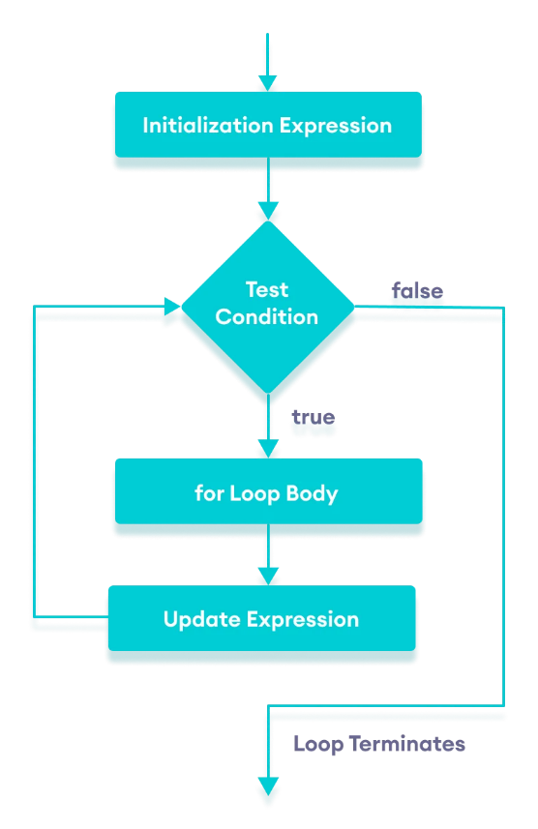
while loop: The JavaScript while loop iterates the elements for the infinite number of times. It should be used if number of iterations is not known. The loop will continue to execute until the condition becomes false.
Syntax:-
while (condition) {
// body of loop
}

Note: Make sure that the condition within the while loop becomes false at some point; otherwise, you might create an infinite loop, which can cause your program to hang or crash.

do while loop: The do while loop is similar to the while loop. But code is executed at least once whether condition is true or false. because the code block is executed before the condition is check.
Syntax:-
do {
// body of loop
} while(condition)
e.g.,
var i=21;
do{
document.write ( i + "<br/>" );
i++;
}while ( i <= 25 );

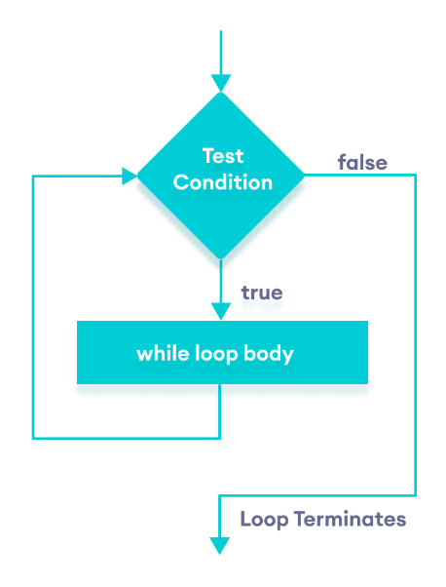
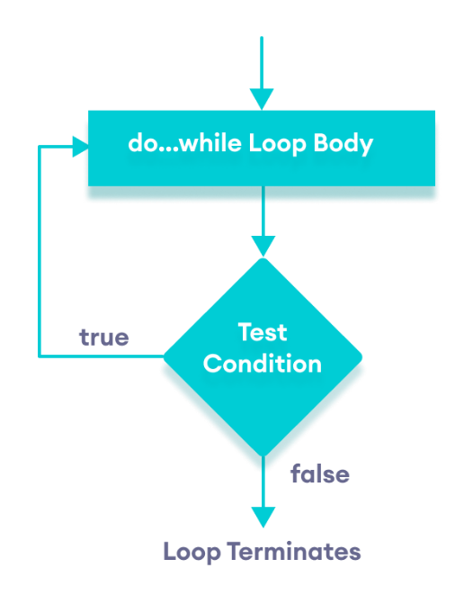
e.g.,
var i=11;
while ( i < 10 )
{ document.write( i + "<br/>" );
i++;
}

for in loop:

for of loop:

Functions
A function is a block of code that is designed to perform a specific task or a set of tasks. We can call JavaScript function many times to reuse the code.
Advantages:
1) Code reusability: Function makes the code reusable. You can declare it once and use it multiple times.
2) Less coding: It makes our program compact. We don’t need to write many lines of code each time to perform a common task. Function makes the program easier as each small task is divided into a function.

Function Declaration:
You can declare a function using the function keyword, followed by the function name. The function name should follow the same rules as variable names in JavaScript. Function names can contain letters, digits, underscores, and dollar signs (same rules as variables).
Syntax:-
function nameOfFunction (para1, para2, para3,…) {
// function body
}

Function Parameters:
A function can also be declared with parameters. A parameter is a value that is passed when declaring a function. Parameters are listed inside the parentheses and separated by commas.
e.g.,
function greet(name) {
console.log(`Hello, ${name}!`);
}
Note: When a value is passed when declaring a function, it is called parameter.
And when the function is called, the value passed is called argument.

Function Arguments:
When you call a function, you provide actual values called arguments. These arguments are passed into the function when it's invoked.
e.g.,
greet("Alice"); // Output: Hello, Alice!

Function Expression:
functions can also be assigned to variables. These are called function expressions.
e.g.,
// program to find the square of a number
const x = function (num) {
return num * num ;
};
console.log(x(4)); // function call through variable name
In the above program, variable x is used to store the function. Here the function is treated as an expression. And the function is called using the variable name.

Arrow Functions:
ES6 introduced arrow functions, which provide a more concise syntax for creating functions. They are especially useful for anonymous functions and have a shorter syntax. e.g.,
// program to find the square of a number
const x = (num) => return num * num ;
console.log(x(4)); // function call through variable name

Function Return Value:
A function can optionally return a value using the return keyword. This value can be of any data type. If any return statement you are not provided, the function returns undefined.
The return statement denotes that the function has ended. Any code after return is not executed.
e.g.1,
function add(a, b) {
return a + b;
}
console.log(add(3, 5)); // Output: 8
e.g.2,
function add(a, b) {
console.log(a + b); // Output: 8
}
console.log(add(3, 5)); // Output: Undefined

Function Hoisting:
In java script, the concept of “function hoisting” is related to how functions are treated during the compilation and execution phases of the code.
During the compilation phase, JavaScript scans through your code to identify function and variable declarations. It sets up memory space for these functions and variables before the code is executed. This process is called hoisting.
However, it’s important to note that only the declarations are hoisted, not the initialization.
Function Declaration: When you declare a function using function keyword, the entire function body is hoisted along with its name.
This means you can call the function before its actual declaration in the code.
e.g.,
sayHello(); // This works even through the function is called before the declaration.

function sayHello(){
console.log(“Hello!”);
}
Function Expression: function expression is not hoisted in the same way as function declaration.
Only the variable declaration is hosted, not the function itself.
If you attempt to call the function before its declaration, it throws an error.
e.g.,
sayHello(); // This will throw an error

var sayHello = function (){
console.log(“Hello!”);
};

Variable Declaration/Hosting: Variable declarations are also hoisted to the top of their containing scope during the compilation phase. This means that you can access and reference a variable before it is formally declared in your code. However, the variables are initialized with the value `undefined` until the assignment statement is reached.
Variable declared using `let` and `const` are hoisted, but they are not accessible before their declaration point. e.g.,
console.log(age); // Output: undefined
var age = 25;

Function hosting VS Variable hosting: Function hoisting and Variable hoisting are concepts related to the behaviour of declarations in JavaScript during the compilation phase.
However, function declarations are hoisted before variable declarations. If a function and a variable with the same name exist in the same scope, the function declaration takes precedence.
console.log(age); // Error: age is not defined

console.log(age); // Throws a Reference Error
let age = 25;

Callback Functions:
Functions can be passed as arguments to other functions, known as callback functions. This is commonly used for asynchronous operations(such as Reading files, Making network requests, or Handling user interactions), Event handling, and Functional programming.
e.g.,
// This function display the result
function processResult(result){
console.log(`Processed Result is: ${result}`);
}
// It receive "Shivam saini" into data variable and processResult function into the callBack.
function performTask(data, callBack){
const processedData=data.toUpperCase();
callBack(processedData);
}
// passing data and function(processResult) as an argument to then another function(performTask).
performTask("Shivam saini", processResult);

Anonymous function:
Function expression without a name is called "Anonymous functions". They can be used as arguments to other functions or assigned to variable.
e.g.,
// Anonymous function declaration and definition.
const fun= function(){
console.log("Hello I am Anonymous Function!");
}
// Anonymous function call
fun();
Closures:
Closures are a powerful concept in JavaScript. They allow a function to remember the variables from its parent scope even after that parent function has finished executing.
To understand closures, you need to understand the concept of lexical scope. Lexical scope refers to the idea that functions can access variables and functions defined in their outer(enclosing) scope. This is determined by where the function is defined, not where it is executed.
Creating a closure:
A closure is created when a function is defined within another function and its “captures” variables from its containing scope. The inner function has access to the variables from the outer function even after the outer function has finished executing.
e.g.,
function counter(){
let count = 0;
return function(){
return ++count;
}
}
const increment = counter(); // Create a closure
console.log( increment()); // Output: 1
console.log( increment()); // Output: 2

Recursive function: A recursive function is a function that calls itself during its execution.
Base Case: This is the termination condition that defines when the recursive function should stop calling itself and start returning values. It provides a stopping condition that prevents the recursive function from calling itself infinitely.
Recursive Case: This is the part of the function where it calls itself with modified arguments. The goal of the recursive case is to break down the original problem into smaller, simpler instances of the same problem. e.g.,
function factorial( n ){
if( n==0 ){ // Base case: factorial of 0 is 1
return 1;
}
return n * factorial(n – 1); // Recursive case: factorial of n is n * factorial of (n-1)
}
console.log( factorial(5) ); // Output: 120
Object
Objects are used to represent real-world entities, concepts, or any structured information in a program. Objects provide a way to group data and behaviour together, promoting modularity and encapsulation.
JavaScript is an object-based language. Everything is an object in JavaScript.
Creating Objects in JavaScript:- There are 3 ways to create objects in JS —
By object literal
By creating instance of Object directly (using new keyword)
By using an object constructor (using new keyword)

Object Literal: An object literal is a syntax in JavaScript for creating and initializing objects.
The simplest way to create an object is by using an object literal, which is a comma-separated list of key-value pairs enclosed in curly braces {}.
Syntax:-
objectName={
property1 : value1,
property2 : value2,
-----------------------
propertyN : valueN
};
or
objectName ={ property1 : value1, property2 : value2, … propertyN : valueN };
e.g.,
const person = {
firstName: "John",
lastName: "Doe",
age: 30,
sayHello: function() {
console.log(`Hello, my name is ${this.firstName} ${this.lastName}.`);
}
};
2) By creating instance of Object: Here, the new keyword is used to create object.
Syntax: objectName=new Object();
e.g.,
var emp=new Object();
emp.id=101;
emp.name="Shiva saini";
emp.salary=50000;
console.log(emp.id+" "+emp.name+" "+emp.salary);

3) By using an Object constructor: you need to create function with arguments. Each argument value can be assigned in the current object by using this keyword. The this keyword refers to the current object.
e.g.,
function emp(id, name, salary) {
this.id = id;
this.name = name;
this.salary = salary;
}
const e = new emp(103, "Vimal Jaiswal", 30000);
console.log(e.id + " " + e.name + " " + e.salary);

Accessing Object Properties: You can access object properties using dot notation
( object.property ) or bracket notation ( object[ "property" ] ).
e.g.,
console.log( person.firstName ); // John
console.log( person["age"] ); // 30

Object Methods:
Functions that are stored as values in an object are called methods. Methods can perform actions related to the object and access its properties using the this keyword.
Syntax:- objectName.methodName();
e.g.,
person.sayHello(); // Hello, my name is John Doe.

Note: If you access a method without the () parentheses, it will return the function definition.
When defining methods in objects, the this keyword refers to the object itself. In JavaScript, this is not a variable. It is a keyword. You cannot change the value of this.
Adding and Modifying Properties: You can add new properties or modify existing ones using assignment. e.g.,
person.job = "Engineer";
person.age = 31;

Deleting Properties: Properties can be removed from an object using the delete keyword.
e.g., delete person.job;

JavaScript Nested Objects: An object can also contain another object.
e.g.,
const student = {
name: 'John', age: 20,
marks: { // Nested object
science: 70, math: 75
}
}
// accessing property of student object
console.log( student.marks ); // {science: 70, math: 75}
// accessing property of marks object
console.log( student.marks.science ); // 70

Object Constructors: Object constructors are functions used to create multiple instances of objects with similar structure and behaviour. The new keyword is used to create instances from constructors. e.g.,
function Car(make, model) {
this.make = make;
this.model = model;
}
const Car1 = new Car("Toyota", "Camry");
const Car2 = new Car("Toyota", "Camry");

Object Prototypes and Classes:
JavaScript uses prototype-based inheritance, where objects can inherit properties and methods from other objects. ES6 introduced class syntax, which provides a more structured way to define object constructors and prototypes.
e.g.,
class Animal {
constructor(name) { // This is a constructor
this.name = name;
}
makeSound() { // This is a method of Animal class
console.log("Some generic animal sound.");
}
}
class Dog extends Animal {
makeSound() { // This is a method of Dog class
console.log("Woof!");
super.makeSound(); // Super keyword is used to call parent class method
}
}
const myDog = new Dog("Buddy");
myDog.makeSound();
console.log(myDog.name);

Output: Woof!
Some generic animal sound.
Buddy

Date object methods
In JavaScript, the Date is a built-in object. It is not a class in the traditional object-oriented programming sense. When you create a new Date object, you are essentially creating an instance of the Date object. Date objects are created with the new Date() constructor.
e.g., const currentDate=new Date();
In JavaScript, the Date object can be used to get year, month and day. You can display a timer on the webpage by the help of JavaScript Date object.
You can use different Date constructors to create date object.
new Date()
new Date(date string)
new Date(year, month)
new Date(year, month, day)
new Date(year, month, day, hours)
new Date(year, month, day, hours, minutes)
new Date(year, month, day, hours, minutes, seconds)
new Date(year, month, day, hours, minutes, seconds, ms)
new Date(milliseconds)

JavaScript Date Methods

var today=new Date();
console.log( today.toString() ); // Thu Aug 17 2023 15:45:07 GMT+0530 (India Standard Time)
console.log( today.toLocaleString() ); // 17/08/2023, 15:53:07
console.log(today.toTimeString() ); // 15:53:07 GMT+0530 (India Standard Time)
console.log( today.toLocaleTimeString() ); //15:53:07
console.log( today.toDateString()) ); // Thu Aug 17 2023
S.No. | Methods | Description
 | getDate() | It returns the integer value between 1 and 31 that represents the day for the specified date on the basis of local time.
 | getDay() | It returns the integer value between 0 and 6 that represents the day of the week on the basis of local time.
 | getFullYears() | It returns the integer value that represents the year on the basis of local time.
 | getHours() | It returns the integer value between 0 and 23 that represents the hours on the basis of local time.
 | getMilliseconds() | It returns the integer value between 0 and 999 that represents the milliseconds on the basis of local time.
 | getMinutes() | It returns the integer value between 0 and 59 that represents the minutes on the basis of local time.
 | getMonth() | It returns the integer value between 0 and 11 that represents the month on the basis of local time.
 | getSeconds() | It returns the integer value between 0 and 59 that represents the seconds on the basis of local time.
 | setDate() | It sets the day value for the specified date on the basis of local time.
 | setDay() | It sets the particular day of the week on the basis of local time.
 | setFullYears() | It sets the year value for the specified date on the basis of local time.
 | setHours() | It sets the hour value for the specified date on the basis of local time.
 | setMilliseconds() | It sets the millisecond value for the specified date on the basis of local time.
 | setMinutes() | It sets the minute value for the specified date on the basis of local time.
 | setMonth() | It sets the month value for the specified date on the basis of local time.
 | setSeconds() | It sets the second value for the specified date on the basis of local time.
 | toString() | It returns the date in the form of string.
 | toDateString() | It returns the date portion of a Date object.
 | toTimeString() | It returns the time portion of a Date object.
 | toLocaleString() | It returns the date and time portion of a Date object.
 | toLocaleTimeString() | It returns only time of a Date object.
 | valueOf() | It returns the primitive value of a Date object.
String Object Methods
The JavaScript string is an object that represents a sequence of characters. Strings are useful for holding data that can be represented in text form. Some of the most-used operations on strings are to check their length, to build and concatenate them using the + and += string operators, checking for the existence or location of substrings with the indexOf() method, or extracting substrings with the substring() method.
String is immutable—
Strings immutable means that strings cannot be changed once they are created.
For Example:
// Create a string
let myString = "Hello, world!";
// Try to change a character in the string
myString[0] = "h"; // This will not work!
// Create a new string with the desired change
const newString = myString.replace("Hello", "Goodbye");
// The original string is unchanged
console.log(myString); // "Hello, world!"
// The new string has the desired change
console.log(newString); // "Goodbye, world!"

Why String is immutable?
      - If strings were mutable, unexpected changes to a string's value could occur, leading to potential bugs that are harder to trace.
      - Immutability allows optimizations. For example, when two strings are concatenated, the result can be a new string without modifying the original strings. This is more efficient than creating a new copy of the entire string.
      - Immutable strings make it easier to implement hashing and caching mechanisms.

Strings can be created as primitives, from string literals, or as objects, using the String() constructor with new keyword:
1) By string literal
2) By string object (using new keyword)

1) By string literal: The string literal is created using double quotes or single quotes or using the backtick character ( ` ).
e.g.,
let str1= "Volvo XC60"; // Double quotes
let str2= 'Volvo XC60'; // Single quotes
console.log( typeof(str1) ); // string
let str3 = "It's alright";
let str4 = "He is called 'Johnny' ";
let str5 = 'He is called "Johnny" ';

JavaScript will misunderstand this string:
let text = "We are the so-called "Vikings" from the north."; // Error
The solution to avoid this problem, is to use the backslash escape character(\).
\' ' Single quote
\" " Double quote
\\ \ Backslash
\n for newline
\t for tab
let text = "We are the so-called \"Vikings\" from the north.";
Output: We are the so-called "Vikings" from the north.

2) By String object (using new keyword): new keyword is used to create instance of string.
e.g.,
let str1=new String("string literal");
console.log(typeof(str1)); // object
console.log(str1.length); // 14

Template Literals:
Template literals, introduced with backticks, allow embedding expressions within strings using ${} syntax. Example: -
let variable = 42;
let templateLiteral = `The value is: ${variable}`;

Character access
There are two ways to access an individual character in a string:
- Using charAt() method:
Example: - "cat".charAt(1); // gives value "a"
- using bracket notation for character access: - The other way is to treat the string as an array, where individual characters correspond to a numerical index:
Example: - "cat".[1]; // gives value "a"

Comparing strings
In JavaScript, comparison operators, such as >, <, >=, and <=, work on strings by performing lexicographical (dictionary) comparisons based on the Unicode values of the individual characters.
Note that all comparison operators, including === and ==, compare strings case-sensitively. A common way to compare strings case-insensitively is to convert both to the same case (upper or lower) before comparing them.

Lexicographical Comparison:
- Strings are compared character by character from left to right.
- The Unicode code points of the characters are compared.
Unicode Code Points:
- Each character in a string has a corresponding Unicode(not same as ASCII) code point, which is a numerical value representing that character.
For Example, 1: -
const word1 = 'hello';
const word2 = 'world';
console.log(word1 < word2); // false

firstly, Unicode are compared of first character of Both Strings.
h < w
104
119
because Unicode of h is less than w. so, first string is less than second string.

For Example, 2: -
const word1 = 'hello';
const word2 = 'hello';
console.log(word1 == word2); // false

firstly, Unicode are compared of first character of Both Strings.
h == h
104
104
because Unicode of h is equal to h. so, second character of both strings compare.
e == e
101
101
than next character is compared……. so on.
If all characters are same, both strings are same.

Difference between ‘String Literal’ and ‘String by using new keyword’ basic on memory representation

Example of String literal—
let homeAddress= 'Sherpur';
let permanantAddress= 'Sherpur';

sherpur
@16709
Heap Memory
Stack Memory
homeAddress
PermanentAddress

Example of String by using new keyword —
let homeAddress= new String('Sherpur');
let permanantAddress= new String('Sherpur');

sherpur

@91583
Heap Memory
Stack Memory
homeAddress
PermanentAddress
sherpur
@91589
String primitives and String objects also give different results when using eval().
const s1 = "2 + 2"; // creates a string primitive
const s2 = new String("2 + 2"); // creates a String object
console.log(eval(s1)); // returns the number 4
console.log(eval(s2)); // returns the string "2 + 2"

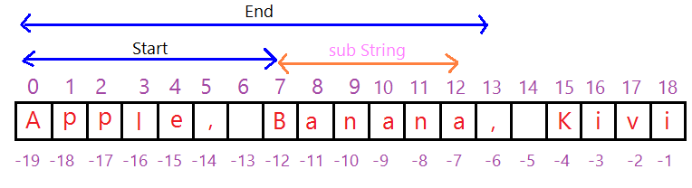
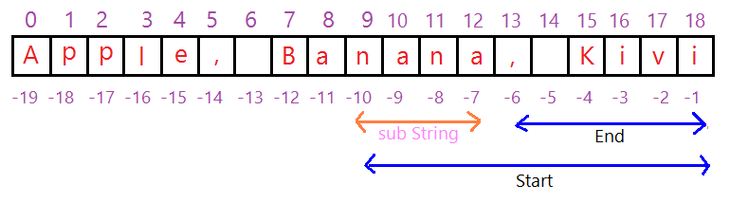
Extracting String Parts: There are 3 methods for extracting a part of a string--
slice(start, end)
substring(start, end)
substr(start, length)

1) slice(start, end):
let text = "Apple, Banana, Kiwi";
let part = text.slice(7, 13);
console.log(part); // Banana

let text = "Apple, Banana, Kiwi";
let part = text.slice(7);
console.log(part); // Banana, Kiwi

// If a parameter is negative, the position is counted from the end of the string:
let text = "Apple, Banana, Kiwi";
let part = text.slice(-5);
console.log(part); // Kiwi

let text = "Apple, Banana, Kiwi";
let part = text.slice(-10, -6);
console.log(part); // Output: nana

// when we use negative indices, it refers to counting from the end of the string. So, -1 refers to the last character in the string, -2 refers to the second last character, and so on.
-12: Counting from the end, the 12th character from the end would be 'a'.
-6: Counting from the end, the 6th character from the end would be the comma ','. This means it will extract characters starting from the 'a' (at index -12) up to, but not including, the comma ',' (at index -6).

substring(start, end): substring() is similar to slice(). The difference is that if start and end values are less than 0, they treated as 0 in substring().
let text = "Apple, Banana, Kiwi";
let part = text.substring(-10, 5);
console.log(part); // Apple

In the both condition the result will be same, because it consider negative value(<0) as zero(0).
Or let text = "Apple, Banana, Kiwi";
let part = text.substring(5, -10);
console.log(part); // Apple

let text = "Apple, Banana, Kiwi";
let part = text.slice(5, -10);
console.log(part); // , Ba

let text = "Apple, Banana, Kiwi";
let part = text.slice(-10, 5);
console.log(part); Note: Nothing show

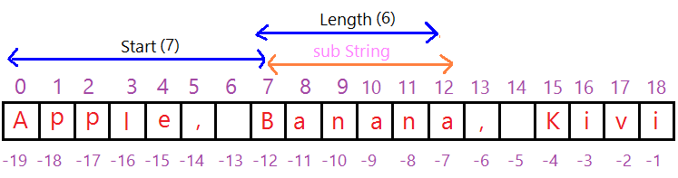

let text = "Apple, Banana, Kiwi";
let part = text. substring(7);
console.log(part); // Banana, Kiwi

let text = "Apple, Banana, Kiwi";
let part = text. substring(-7);
console.log(part); // Apple, Banana, Kiwi

substr(start, length): substr() is similar to slice().The difference is that the second parameter specifies the length of the extracted part.
start: This is the index at which the extraction should begin. If the index is negative, it counts from the end of the string.
Length: This is the number of characters to be extracted from the string. If the length is greater than the remaining characters in the string, the method extracts until the end of the string.
If you provide a negative value for the length parameter in the substr() method, it will be treated as zero(0).

let str = "Apple, Banana, Kiwi";
let part = str.substr(7,6);
console.log(part); // Banana

let str = "Apple, Banana, Kiwi";
let part = str.substr(7);
console.log(part); // Banana, Kiwi

let str = "Apple, Banana, Kiwi";
let part = str.substr(-7);
console.log(part); // a, Kiwi

String Search Methods
indexOf()
lastIndexOf()
search()
match()
matchAll()
includes()
startsWith()
endsWith()

indexOf(substring, startIndex) or indexOf(substring): The indexOf() method in JS is used to find the position of a specific piece of text (substring) within a large text (String). It tells you where the substring starts inside the string. It start searching from left to right.
substring: This is the text you are looking for inside the large text.
startIndex: This is an optional parameter. It tells the method, the searching would be start from which index. If you are not provide starting index, It will start searching form 0.

If a match is found for the entire substring, the method returns the index of the first character of the matched substring. and if the substring is not found, the method returns -1.
Keep in mind that the indexOf() method performs a case-sensitive search.

let str = "Apple, Banana, Kiwi";
console.log( str.indexOf("Banana") ); // Output: 7

let str = "Apple, Banana, Kiwi";
console.log( str.indexOf("Banana", 11) ); // Output: -1

lastIndexOf(substring, startIndex) or lastIndexOf(substring): It is same as indexOf() method. But the difference is, It start searching from last (right to left).

search(regexp): It returns the index of the first occurrence of the substring within the string, or -1 if the substring is not found. This method uses a regular expression to perform the search. The search() method is case sensitive. e.g.,
var str = "Hello, this is a sample string.";
console.log( str.search("is") ); // Output: 9
If the search value is a string, that will be converted to a regular expression.

e.g.,
var str = "Hello, this is a sample string.";
var index = str.search(/is/);
console.log(index); // Output: 9
In this example, the search() method is used with a regular expression pattern /is/. It behaves the same as the first example.
e.g.,
let text = "Mr. Blue has a blue house";
let position = text.search( /blue/i );
console.log(position) // Output: 4

/blue/i: This is a regular expression pattern enclosed in forward slashes. The i at the end of the pattern is a flag that makes the search case-insensitive, meaning it will match both "blue" and "Blue".

Ques. The Difference Between String search() and String indexOf()?
Ans. The search() cannot take a start position argument. while the indexOf() method cannot search against a regular expression.

4) match(regexp): The match() method returns an array of substrings that match the regular expression, along with additional information: If no matches are found, it returns null.
If matches are found: The first element of the returned array is the entire matched substring.
e.g.,
var str = "Hello, this is a sample string.";
var matches = str.match(/is/);
console.log(matches); // Output: [ 'is', index: 8, input: 'Hello, this is a sample string.' ]

The index property indicates the starting index of the match, and the input property contains the original input string.
e.g.,
var str = "Hello, this is a sample string.";
var matches = str.match(/is/g);
console.log(matches); // Output: [ 'is', 'is' ]

Here, the g flag in the regular expression makes the match() method return all occurrences of "is" as an array. The resulting array contains each matched substring.
e.g.,
var str = "Hello, 123, world.";
var matches = str.match(/\d+/);
console.log(matches); // Output: [ '123', index: 7, input: 'Hello, 123, world.' ]

the regex \d+ matches one or more digits. The match() method returns an array containing the matched number '123'. The index property indicates the starting index of the match, and the input property contains the original input string.

6) include(searchString, position): it is same as indexOf() but the difference is, It returns a boolean value indicating whether the substring is found within the given string or not. The position argument is optional. It is case sensitive.

7) startsWith(searchString, position): It is used to determine whether a given string starts with a specific substring. It returns a boolean value indicating whether the string start with the specified substring. The position argument is optional. It is case sensitive.
e.g.,
var str = "Hello, this is a sample string.";
var startsWithHello = str.startsWith("Hello");
console.log(startsWithHello); // Output: true

e.g.,
var str = "Hello, this is a sample string.";
var startsWithThis = str.startsWith("is", 8);
console.log(startsWithThis); // Output: true

8) endsWith(searchString, length): It is used to determine whether a given string ends with a specific substring. It returns a boolean value indicating whether the string ends with the specified substring.
length (optional): This is an optional parameter that specifies the position within the string at which to stop comparing.
e.g.,
var str = "Hello, this is a sample string.";
var endsWithString = str.endsWith("string.");
console.log(endsWithString); // Output: true

e.g.,
var str = "Hello, this is a sample string.";
var endsWithIs = str.endsWith("is", 14);
console.log(endsWithIs); // Output: true

replace(searchValue, newValue): The replace() method is a built-in(pre-defined) method in JavaScript that is used to replace a specified substring or regular expression pattern with a new substring within a given string. This method returns a new string without change the original string.
Syntax:- string.replace(searchValue, newValue)

string: This is the string in which you want to perform replacements.
searchValue: This is the substring or `regular expression pattern` you want to search within the string.
newValue: This is the new substring that will replace with the searchValue.
e.g.,
var str = "Hello, this is a sample string.";
var newStr = str.replace("is", "was");
console.log(newStr); // Output: "Hello, thwas is a sample string."

The replace() method only replaces the first occurrence of the searchValue. To replace all occurrences, you can use a regular expression with the global flag (/g).
e.g.,
var str = "Hello, this is a sample string.";
var newStr = str.replace(/is/g, "was");
console.log(newStr); // Output: "Hello, thwas was a sample string."

e.g.,
var str = "Hello, this is a sample string.";
var newStr = str.replace(/i/g, "");
console.log(newStr); // Output: "Hello, ths s a sample strng."

split(separator, limit): It is used to split a string into an array of substrings based on a specified delimiter. The delimiter can be a character, a regular expression pattern, or a string.
separator (optional): This is an optional parameter that specifies the delimiter at which to split the string. It can be a character, a regular expression pattern, or a string.
limit (optional): This is an optional parameter that specifies the maximum number of substrings to include in the resulting array.
The split() method returns an array of substrings obtained by splitting the original string using the specified delimiter.
e.g.,
var str = "apple,banana,orange";
var fruits = str.split(",");
console.log(fruits); // Output: [ 'apple', 'banana', 'orange' ]
In this example, the split() method is used to split the string "apple,banana,orange" into an array of substrings using the comma , as the delimiter. The resulting array is ['apple', 'banana', 'orange'].

e.g.,
var str = "apple_banana_orange";
var fruits = str.split("_", 2);
console.log(fruits); // Output: [ 'apple', 'banana']
The limit parameter is set to 2, so only the first two substrings are included in the resulting array.

trim(): It is used to remove whitespace characters (spaces, tabs(\t), newlines(\n)) from both the beginning and the end of a string. It returns a new string with the whitespace trimmed.
e.g.,
var str = " Hello, world! ";
var trimmedStr = str.trim();
console.log(trimmedStr); // Output: "Hello, world!"

e.g.,
var str = "\t\tTabs and spaces\t\t";
var trimmedStr = str.trim();
console.log(trimmedStr); // Output: "Tabs and spaces"

S.No. | Methods |  | Description
 | length (variable) |  | Return the length of string.
 | charAt( index ) |  | It returns the character at the specified index.
 | charCodeAt( index ) |  | It is used to retrieve the Unicode value (code point) of a single character at a specific index within a string. If the index is out of range it returns ‘Nan’.
 | fromCharCode(code1, code2,… ) |  | This method is a static method of the String object. This method essentially performs the opposite operation of the charCodeAt() method, which receieve the Unicode value of a character.
 | concat( str1, str2, …) |  | Combines multiple strings and returns a new concatenated striing.
 | toLowerCase(string) |  | It converts the given string into lowercase letter.
 | toLocaleLowerCase() |  | It converts the given string into lowercase letter on the basis of host?s current locale.
 | toUpperCase(string) |  | It converts the given string into uppercase letter.
 | toLocaleUpperCase() |  | It converts the given string into uppercase letter on the basis of host?s current locale.
 | indexOf(substring, startIndex) |  | If substring is found, It will return the index of first character of given substring that are found in main String. Otherwise it return -1.
 | lastIndexOf(substring, startIndex) |  | It is same as indexOf() method, but the difference is It start searching form right to left.
 | substr(start, length) |  | It is used to fetch the part of the given string on the basis of the specified starting position and length.
 | substring(start, end) |  | It is used to fetch the part of the given string on the basis of the specified index.
 | slice(start, end) |  | It is used to fetch the part of the given string. It allows us to assign positive as well negative index.
 | search(regexp) |  | It searches a specified regular expression in a given string and returns its position if a match occurs.
 | toString() |  | It provides a string representing the particular object.  This method is available on most data types, including numbers, booleans, arrays, objects, and more.
 | valueOf() |  | It provides the primitive value of string object.
 | replace(searchValue, newValue) |  | It replaces a given string with the specified replacement.
 | split( separator, limit) |  | It splits a string into substring array, then returns that newly created array.
 | trim() |  | It removes the white space from the left and right side of the string.
 | trimEnd() | Returns a string with removed whitespaces from the end
 | trimStart() | Returns a string with removed whitespaces from the start
 | localeCompare()

Note: All string methods return a new value.
They do not change the original variable.

S.No. | Methods | Description
 | fixed() | This method was used to create a string where the text content is displayed using the HTML <tt> (teletype) tag, which renders the text in a fixed-width font.
 | small() | The small() method returns a string embedded in a <small> tag.
 | bold() | The bold() method returns a string embedded in a <b> tag.
 | fontcolor( color ) | The fontcolor() method returns a string embedded in a <font> tag. e.g., <font color="colorvalue">string</font>
 | fontsize( size ) | The fontsize() method returns a string embedded in a <font> tag. e.g., <font size="size">string</font> (size= 1 to 7)
 | italics() | The italics() method returns a string embedded in an <i> tag.
 | link( Url ) | The link() method returns a string embedded in an <a> tag.
 | strike() | The strike() method returns a string embedded in a <strike> tag. Output of strike tag:- Rs 500
 | sup() | The sup() method returns a string embedded in a <sup> tag.
 | sub() | The sub() method returns a string embedded in a <sub> tag.
 | repeat( count ) | The repeat() method returns a string with a number of copies of a string.

Number Object Methods
In JavaScript, numbers are a primitive data type that represents numeric values. Numbers in JavaScript can be integers or floating-point values.
JavaScript has two special numeric values:
- Infinity: Represents positive infinity, which is a value greater than any other number.
Example: - let positiveInfinity = Infinity;
- NaN (Not-a-Number): Represents a value that is not a valid number. It is the result of an undefined or unrepresentable mathematical operation.
Example: - let notANumber = NaN;
There are two ways to create a number in JavaScript:
- Using a literal: A number literal is a number that is written directly in your code.
Example: - const number = 10;
- Using the Number() constructor: The Number() constructor can be used to convert a string or another value to a number.
You can also use the Number() constructor to create a number. The Number() constructor takes a string as an argument and returns a number.
let num = Number("10");
You can also use the Number() constructor to create a number from a hexadecimal or octal value.
const myNumber = Number("0xA");
Static Method of Number
Static Method | Example | Result
isNaN(value) | Number.isNaN(NaN) | true
isNaN(value) | Number.isNaN(123); | false
isFinite(value) | Number.isFinite(42) | true
isFinite(value) | Number.isFinite(Infinity) | false
isInteger(value) | Number.isInteger(5) | true
isInteger(value) | Number.isInteger(5.5) | false
parseInt(string, radix) | Number.parseInt("10") | 10 | radix (optional): An integer between 2 and 36 that represents the base of the number system. and Js convert string to given number system basic on radix. If radix is not mention it convert in decimal  by default.
parseInt(string, radix) | Number.parseInt("10", 2) | 1010
parseInt(string, radix) | parseInt("71", 8); | 57
parseInt(string, radix) | parseInt("0x1a"); | 26 | In above String "0x" Prefix: Indicates that the number is in hexadecimal (base-16).  So, result will be hexadecimal to decimal.
parseInt(string, radix) | parseInt("42abc"); | 42 | The characters "abc" are ignored because they are not part of a valid numeric representation. And stop parsing.
parseInt(string, radix) | parseInt("abc"); | NaN | NaN means Not a Number.
parseFloat(string) | Number.parseFloat("3.14") | 3.14

Non-Static Method of Number: In JavaScript, the Number object is a wrapper object that represents numeric values and provides various non-static methods for performing operations on numbers.
Method | Example | Result
toFixed(digits) | 7.12345.toFixed(2); | 7.12 | Formats a number using fixed-point notation with a specified number of digits after the decimal point.  The original number is not modified; instead, a new string is created.  The argument digits must be a non-negative integer. If it is negative or not a number, toFixed() will throw a RangeError.
toFixed(digits) | 71.toFixed(2); | Error
toFixed(digits) | (71).toFixed(2); | 71.00
toFixed(digits) | 7.12345.toFixed(0); | 7
toLocaleString() | 1234567.89.toLocaleString() | "1,234,567.89" | It is used to format a number using locale-specific conventions, such as grouping separators, decimal separators, and formatting based on the user's locale. This method is particularly useful when you want to display numbers in a user-friendly way.
toLocaleString() | (1000000).toLocaleString() | “1,000,000”
toLocaleString() | (1000000).toLocaleString('en-IN') | “10,00,000”
toPrecision(precision) | 123.8746.toPrecision(5); | 123.87 | It is used to format a number using precision notation with a specified total number of digits. This method returns a string.  precision: An optional parameter specifying the total number of digits (including both the integer part and the fractional part).
toPrecision(precision) | 123.8756.toPrecision(5); | 123.88
toPrecision(precision) | 7.8.toPrecision(4); | 7.800
toPrecision(precision) | 12345.6789. toPrecision(4); | 1.235e+4
toString([radix]) | 42.toString(); | “2” | Converts a number to a string, optionally with a specified radix (base). radix (optional): An integer between 2 and 36 that represents the base of the numeral system. And by the default is 10.
toString([radix]) | 42.toString(2); | “101010”
toString([radix]) | 42.toString(8); | “52”
toString([radix]) | 42.toString(16); | “2a”
toExponential(digits) | 12345.toExponential(2); | 1.23e+4 | Converts a number to exponential notation with a specified number of digits after the decimal point.
valueOf() | new Number(42).valueOf(); | 42 | Returns the primitive value of a Number object.

Math Object Methods
The methods and properties provided by the Math object in JavaScript are all static, meaning they are called directly by the Math object itself. The Math object doesn't have instance-specific methods. And you can’t create instance of Math object.

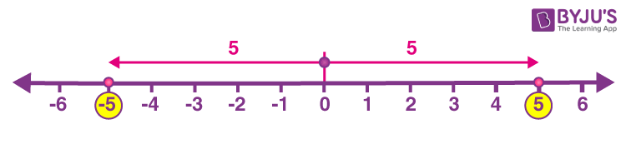
What is absolute value?
The absolute value of a number is its distance from zero, without considering direction. For example, the absolute value of 5 is 5, and the absolute value of -5 is also 5. This is because both 5 and -5 are 5 units away from zero on a number line.
floor
Ceil
Absolute value is always a non-negative number. This is because distance is always a non-negative quantity.

What is round value?
Rounding a value means making a number simpler or easier to work with by adjusting it to the nearest whole number or a specific decimal place. It involves determining which whole number or decimal place is closest to the original value.
For example:
- Whole Number Rounding: If you have the number 4.6, rounding it to the nearest whole number would give you 5 because 4.6 is closer to 5 than to 4.
- Decimal Rounding: If you have the number 3.14 and you want to round it to one decimal place, you would get 3.1 because it is closer to 3.1 than to 3.2.

Some Important Static Methods of Math object:
Syntax | Example | Result |  | Description
Math.random() | Math.random() | 0.8582553088008267 |  | The returned value is a decimal number greater than or equal to 0 and less than 1.
Math.abs(number) | Math.abs(5) | 5 |  | This method is used to obtain the absolute value of a number. it always returns the non-negative value of a given number.
Math.abs(number) | Math.abs(-5) | 5
Math.abs(number) | Math.abs(0) | 0
Math.round(number) | Math.round(4.3) | 4 |  | The Math.round() method takes a decimal number as input and rounds it to the nearest integer. It follows standard rounding rules:  If the fractional part of the number is 0.5 or greater, the number is rounded up; otherwise, it is rounded down.
Math.round(number) | Math.round(4.5) | 5
Math.round(number) | Math.round(-2.5) | -2
Math.round(number) | Math.round(4.067) | 4
Math.ceil(number) | Math.ceil(3.1) | 4 |  | The name "ceil" stands for "ceiling," indicating that the method returns the smallest integer that is greater than or equal to the specified number.  If the number is already an integer, Math.ceil() simply returns the same integer without any changes.
Math.ceil(number) | Math.ceil(-5.78) | -5
Math.ceil(number) | Math.ceil(-2.5) | -2
Math.ceil(number) | Math.ceil(7) | 7
Math.ceil(number) | Math.ceil(-7) | -7
Math.floor(number) | Math.floor(5.78) | 5 |  | This function is used to round down a number to the nearest integer that is less than or equal to the given number.
Math.floor(number) | Math.floor(5.12) | 5
Math.floor(number) | Math.floor(5) | 5
Math.floor(number) | Math.floor(-5.78) | -6
Math.pow( base, exponent) | Math.pow(2, 3) | 8 |  | This method is used to calculate the power of a given base raised to a specified exponent.
Math.max(value1 ,value2, …) | Math.max(10, 5, 8, 20, 15) |  | 20 |  | It is used to find the minimum value from a set of numbers or to find the maximum value from an array
Math.max(value1 ,value2, …) | Math.max( [10, 5, 8, 20, 15] ) |  | NaN
Math.max(value1 ,value2, …) | let numbers = [10, 5, 8, 20, 15]; Math.max(...numbers); |  | 20
Math.min(value1 ,value2, …) | Math.min(10, 5, 8, 20, 15) |  | 5 |  | It is used to find the minimum value among a set of numbers or to find the minimum value from an array
Math.min(value1 ,value2, …) | Math.min( [10, 5, 8, 20, 15] ) |  | NaN
Math.min(value1 ,value2, …) | let numbers = [10, 5, 8, 20, 15]; Math.min(...numbers); |  | 5
Math.min(value1 ,value2, …) | Math.min(10, 5, 20, 15, true) |  | 1
Math.sqrt(number) | Math.sqrt(25) | 5 |  | This method is used to calculate the square root of a given number. It is important to note that if you provide a negative number as an argument, the method will return NaN (Not a Number).
Math.sqrt(number) | Math.sqrt(true) | 1
Math.sqrt(number) | Math.sqrt(false) | 0
Math.sqrt(number) | Math.sqrt(25.67) | 5.06655701635736

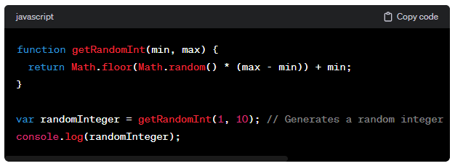
Example to generate a random integer between a minimum (inclusive) and a maximum (exclusive) value:

What is Arrays in Java Script? What are the methods of Array Object?
In JavaScript, an array is a data structure that allows you to store and organize multiple values under a single variable. Arrays are used to store collections of items, such as numbers, strings, objects, or a combination of different data types.
Some important point about an array:
- Array is not immutable like string.
Exp.
const fruits=['mango', 'banana', 'apple'];
fruits[1]='grapes'; // We can modify an Array
console.log(fruits); // [ 'mango', 'grapes', 'apple']
console.log(Object.keys(fruits)); // ['0', '1', '2']
fruits.length = 10; // We can modify array length
console.log(fruits); // ['mango', 'grapes', 'apple', empty x 7]
console.log(fruits[8]); // undefined

- JavaScript arrays are resizable and can contain a mix of different data types.
- JavaScript arrays are not associative arrays or JavaScript arrays are not truly associative arrays in the traditional sense. While they may seem similar to associative arrays found in other programming languages like PHP or Perl.
JavaScript arrays are a special type of object where the keys are strings or integers used as indices.
const student = [];
student['Name'] = 'Shivam saini';
student['DOB'] = '15/01/2002';
console.log(student); // [ Name: 'Shivam saini', DOB: '15/01/2002']
console.log(student.length); // 0

- In JavaScript array-copy operations create shallow copies rather than deep copy.
- Array elements can be access using bracket notation.

Ques. What is shallow copy?
Ans.
Ques. What is deep copy?
Ans.

Static Methods of Array:
Method | Example | Description
Array.from() | const str = "Hello";  const arr = Array.from(str);  // Result: ['H', 'e', 'l', 'l', 'o']  const numbers = [1, 2, 3];  const squaredNumbers = Array.from(numbers, (x) => x * x);  // Result: [1, 4, 9] | This method in JavaScript is a way to create a new array from an existing iterable or array-like object. An iterable is essentially something you can loop over, like an array.  For example, you can convert a string into an array of its characters using Array.from()
Array.of() | // Creates an array with one element [3]  let arr1 = Array.of(3);  let arr2 = Array(3); // Creates an empty array with a length property of 3 | This method is used to create a new array with the elements that you pass to it as arguments.  when you pass a single numeric argument into the Array() constructor, it consider as length of array. So, the Array.of() avoids this confusion.
Array.isArray() | Array.isArray([1, 2, 3, 4]) // true | It returns true if the value is an array, otherwise it returns false.
Non-Static Methods of Array:
Method | Example | Description
push(element) | const arr=new Array(10,20)  console.log(arr.push(30,40,50)) // 5  console.log(arr.push(80)) // 6  console.log(arr);//[ 10, 20, 30, 40, 50, 80] | This method is used to add one or more elements to the end of an array. It modifies the original array and returns the new length of the array.
pop() | const numbers=[ 10, 20, 30, 40, 80 ];  console.log(numbers.pop()); // 80  console.log(numbers);//[10, 20, 30, 40] | It removes the last element from an array and returns that element.
unshift(element) | const arr=new Array(10,20)  console.log(arr.unshift(30,40,50));// 5  console.log(arr.unshift(80)) // 6  console.log(arr); // [ 80, 30, 40, 50, 10, 20 ] | This method is used to add one or more elements to the beginning of an array. It modifies the original array and returns the new length of the array.
shift() | const numbers=[ 10, 20, 30, 40, 80 ];  console.log(numbers.shift()); // 10  console.log(numbers);//[20, 30, 40, 80] | This method is used to remove the first element from the array and return that removed element.
concat() | const array1 = [1, 2, 3],  const array2 = [4, 5, 6];  const array3 = [7, 8, 9];  const newArray1 = array1.concat(array2);  console.log(newArray1); //[1, 2, 3, 4, 5, 6]  const newArray2 = array1.concat(array2, array3);  console.log(newArray2); // [ 1, 2, 3, 4, 5, 6, 7, 8, 9 ] | The concat() method is used to merge two or more arrays into a single array. It does not modify the original arrays but return a new array.
reverse() | const numbers=[ 10, 20, 30, 40, 50 ];  numbers.reverse();  console.log(numbers); // [ 50, 40, 30, 20, 10 ] | The reverse() method is used to reverse the elements of an array. It modifies the original array by reversing the order of its elements, so the last element becomes the first, the second-to-last becomes the second, and so on.
slice(startIndex, endIndex) | const numbers=[ 10, 20, 30, 40, 50 ];  console.log(numbers.slice(0,3)); // [ 10, 20, 30 ]  console.log(numbers); // [ 10, 20, 30, 40, 50 ] | The slice() method is used with arrays to create a new array that contains a sub portion of the original array. It doesn't modify the original array. It crop slice from startInded to (endIndex-1).
splice(start, deleteCount, item1, item2, ...); | const numbers=[ 10, 20, 30, 40, 50 ];  console.log(numbers.slice(0,3)); // [ 10, 20, 30 ]  console.log(numbers); // [ 40, 50 ] | The splice() method is used to modify the contents of an array by removing or replacing existing elements and/or adding new elements at a specified position.
join(separator) | const numbers = [10, 20, 30, 40, 50];  const str=numbers.join() // by default separated by comma (,)  console.log(str); // 10,20,30,40,50  const str1=numbers.join(' < ');  console.log(str1); // 10 < 20 < 30 < 40 < 50 | The join() method is used to concatenate all the elements of an array into a single string. It takes a separator(optional) string as an argument and return a new string by joining the elements of the array together with a specified separator.
toString() | const numbers = [10, 20, 30, 40, 50];  const str=numbers.toString()  console.log(str); // 10,20,30,40,50 | The toString() methods are used to convert an array into a string. It always uses a comma (,) as separator.
toLocaleString() | const data = ['Hello', 1234567.89, new Date()];  console.log(data);  // [ 'Hello', 1234567.89, 2024-02-09 T15:49:37.079Z ]  console.log(data.toLocaleString("en-IN"));  // Hello, 12,34,567.89, 9/2/2024, 9:19:37 pm | This method is used with arrays to convert the elements of the array into strings based on the user's locale language and formatting preferences. If your array contains numbers or dates, toLocaleString() helps you format them according to the user's locale. and if array contains strings, they will not be affect.
indexOf(element) | const fruits = ['apple', 'banana', 'orange']  const position = fruits.indexOf('orange');  console.log(position); // Output: 2 | This method is used to find the index of a specific element within the array.  If the element is not found, the method returns -1.
lastIndexOf(  searchElement, fromIndex ) | const fruits = ['apple', 'banana', 'orange', 'banana', 'grape'];  console.log(fruits.lastIndexOf('banana'));  // Outputs: 3 | This method starts searching from the last. It returns the index of last occurrence element. It returns -1, if element not found. fromIndex is optional.
includes() | const fruits = ['apple', 'banana', 'orange']  console.log(fruits.includes('orange'));  // Output: true | This method is used to check if a particular element is present in the array or not. It returns a boolean value (true or false) based on whether the specified element is found in the array or not.
sort() | let fruits = ['banana', 'apple', 'orange'];  fruits.sort();  console.log(fruits);  // Output: ['apple', 'banana', 'orange']  let numbers = [3, 1, 8, 5];  numbers.sort();  console.log(numbers); // Output: [1, 3, 5, 8] | The sort() method is used to arrange the elements of an array in a particular order. By default, it sorts the elements in ascending order based on their Unicode code points.
forEach()
filter()
map()
reduce()
find()
every()
copyWithin()
at()
fill()

Other Most Important Methods: -
- forEach
- filter
- map
- reduce

- forEach() Method: - The forEach() method is used to iterate over elements in an array. It allows you to perform a specific action for each element in the array without the need for explicit loops.
forEach() always returns undefined and is not chainable.
There is no way to stop or break a forEach() loop other than by throwing an exception.
Take Callback Function:
You provide a function as an argument to forEach(). This function is called a callback function. The callback function is executed once for each element in the array.
Parameters of the Callback Function:
The callback function takes up to three parameters: the current element, the index of the current element, and the array itself. Syntax: -
array.forEach(function(element, index, array) {
// Your code here
});
No Return Value:
forEach() doesn't return anything; it simply iterates over the array.

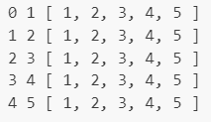
For Example1: - you have an array of numbers and you want to print each number to the console:
const numbers = [1, 2, 3, 4, 5];
numbers.forEach(function (number, index, array) {
console.log(index, number, array);
});
In this example, the callback function is executed for each number in the array, and it prints each number and its index to the console.
Note: you can avoid array parameters.
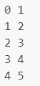
For Example2: - if you want to work with array index and its value.
const numbers = [1, 2, 3, 4, 5];
numbers.forEach(function (number, index) {
console.log(index, number);
});
Note: you can avoid index and array both parameters.

For Example3: - if you want to work with only value.
const numbers = [1, 2, 3, 4, 5];
numbers.forEach(function (number) {
console.log(number);
});
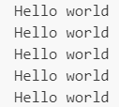
Note: you can avoid all parameters.
For Example4: - It always print ‘Hello world’ (i.e., array.length).
const numbers = [1, 2, 3, 4, 5];
numbers.forEach(function () {
console.log(“Hello world”);
});
Note: How to implement our custom forEach() Method?
Array.prototype.myForEach = function (callbackfun) {
// 'this' refers to the array calling the method
for (let i = 0; i < this.length; i++) {
callbackfun(this[i], i, this);
}
}

// call forEach() Method
const numbers = [1, 2, 3, 4, 5];
numbers.myForEach((value) => {
console.log(value);
});
This function takes one parameter (number), which represents the current element in the array.
The reason this works is that JavaScript still passes all three arguments to call your function, but if you only declare one parameter, only the first argument (number in this case) will be assigned a value, and the other two (index and array) will be ignored.
const numbers = [1, 2, 3, 4, 5],
const nums;
nums = numbers.myForEach((value) => {
return value;
});
console.log(nums); // undefine
- filter() Method: - It allows you to create a new array by filtering out elements from an existing array based on a specified condition.
Syntax: - let newArray = originalArray.filter(callback(element, index, array));
callback: A function that defines the condition for filtering. callback function will be called for each element in the array.
If the callback function returns true for an element, that element is included in the new array. And if the callback function returns false, the element is excluded.
Return value:
- The filter() function returns a new array containing only the elements that passed the condition specified in the callback function.
Example: -
let numbers = [1, 2, 3, 4, 5, 6];
// Using filter to get only even numbers
let evenNumbers = numbers.filter(function (num) {
return num % 2 === 0;
});
OR
let evenNumbers = numbers.filter((num) => num % 2 === 0);
console.log(evenNumbers); // [2, 4, 6]
Example: -
const heros = ['Ironman', 'Superman', 'Hulk', 'Thor', 'Spiderman'];
// Using filter to get word which length is grater than 6
const result = heros.filter((word) => word.length > 6);
console.log(result); // Array ["Ironman", "Superman", "Spiderman"]

Ques. Can we merge two array through passing array to pop method.

Explain difference between slice and splice methods?

Regular Expression(RegExp)
Regular expressions (Regex) are a way of describing patterns in a string of data, which allows you to search for data strings, like email addresses or passwords, that match that pattern.
Regular expressions are a way to describe patterns in a string of data.
Regular expressions allow you to check a string of characters like an e-mail address or password for patterns to see if they match the pattern defined by that regular expression.

How to Create a Regular Expression in JavaScript
There are two ways to create a regular expression in JavaScript. It can either be created with a RegExp constructor, or by using forward slashes ( / ) to enclose the pattern.
REGULAR EXPRESSION CONSTRUCTOR
Syntax: new RegExp(pattern[, flags])
Example
var regexConst = new RegExp('abc');

REGULAR EXPRESSION (REGEX) LITERAL
Syntax: /pattern/flags
Regex Literal Example
var regexLiteral = /abc/;
REGEXP.PROTOTYPE.TEST()
This method is used to test whether a match has been found or not. It accepts a string which we have to test against a regular expression, and it returns true or false depending upon if the match is found or not.
For example:
var regex = /hello/;
var str = 'hello world';
var result = regex.test(str);
console.log(result);
// returns true

REGEXP.PROTOTYPE.EXEC()
This method returns an array containing all the matched groups. It accepts a string that we have to test against a regular expression.
For example:
var regex = /hello/;
var str = 'hello world';
var result = regex.exec(str);
console.log(result);
// returns [ 'hello', index: 0, input: 'hello world', groups: undefined ]
// 'hello' -> is the matched pattern.
// index: -> Is where the regular expression starts.
// input: -> Is the actual string passed.

